Group Members:

Student ID | Name
9454 | Muhammad Muzammil
9744 | Hassam Saqib
9762 | Taqi Ahmed

Project Assignment 2 A

Software Requirements Specification
for
Inventory Management System

11,February 2021

Table of Contents
1. Introduction
2. The General Description
3. Specific Requirements
4. Supporting Information
1. Introduction

1.1 Purpose

This document describes the software requirements for th Inventory Management System (IMS).

1.2 Scope

Inventory Management System which have users who can login to the system and check for records of sales, stock, purchase invoice, suppliers.

http://www.china2thou.com
• Pressman, Roger S., Software Engineering: A Practitioner’s Approach, McGraw-Hill Companies, Inc., 1997.

1.5 Overview

Chapter 2 of the SRS is a brief description of the characteristics of the software to be built, its functions, its users, its constraints and its dependencies.

Chapter 3 is about specific requirements, such as functional requirements, external interface requirements, performance requirements, and also design constraints and quality characteristics.

Finally, chapter 4 includes all the supporting information, such as the Table of Contents, the Appendices, and the Index.

2. The General Description

This section describes the general factors that affect the product and its requirements. This section consists of five subsections that follow. This section does not state specific requirements. Each of the subsections makes those requirements easier to understand, it does not specify design or express specific requirements. Such detail is provided in section 3.

2.1 Product Perspective
The Inventory Management System diagram showing the overview of the system’s modules and the relationship of the system to external interfaces is presented in Figure 2.1.

Figure 2.1 Overview/Architecture Diagram of the IMS
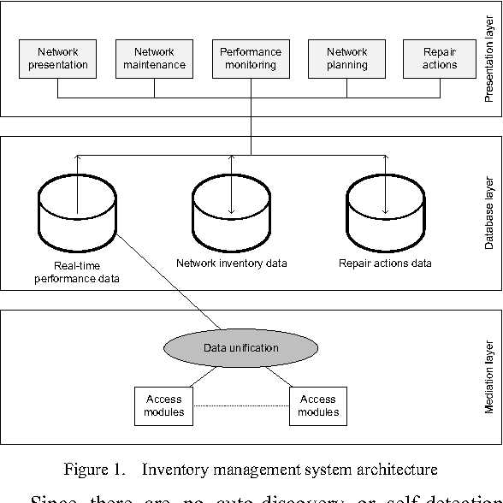

Functions of System Components:

Database:
• Stores data
• Creates reports
• Provides access to data
• Updates information

• Provides access to the database
• Authenticates users

2.2 Product Functions
This section provides a summary of the functions that the software will perform.
2.2.1 Function Relationships
Figure 2.2 to 2.6 depict the relationships among the functions to be implemented by the system.
Figure 2.2 Inventory Management System General Function Relationship/Higher Level Usecase Diagram

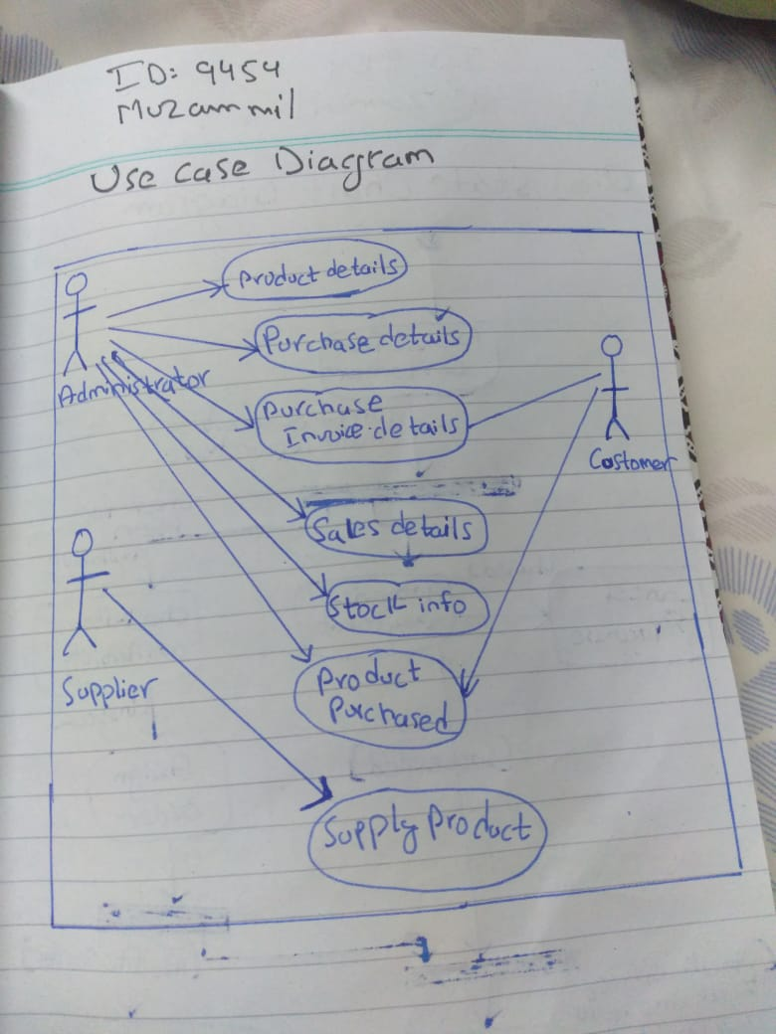

2.2.2 Function Descriptions (Functional Requirement Listings)

2.2.2.1 Log In Function

Description: This function ensures that only authorized users gain access to the Inventory Management databases. An authorized user is a user who has an account on the system. The user must type a valid username and password to gain access.

2.2.2 Module 1: Users

Description: This function allows the system to give access to users who can work with the database, they can login to the inventory management system and check for the stock, update the record, delete and perform search for any specific product.

2.2.3 Module 2: Suppliers/Stock

Description: This function has the ability to maintain the record of already entered stock information, this function has all the information regarding stock of the inventory, update new stock prices, delete the unnecessary item.s

2.2.4 Module 3:

Description: This function take cares of the purchase invoice, this function can show the purchase invoices of items sold in the inventory management system.
We are 3 members in group for Software Engineering project and we have minimum 4 modules in our system. Group leader is working on 2 modules(Suppliers/stock)

2.3 User Characteristics

The main users of the system ensures that only authorized users gain access to the Inventory Management databases. An authorized user is a user who has an account on the system. The user must type a valid username and password to gain access.The graphical interface provides an easy way of using the Inventory Management system with minimum of training.

Assumptions and Dependencies or Business Logic
The assumptions for the project are:
- We can check the record, update, insert, create, edit, delete and also search for the relevant items in our Inventory Management System.
- Main the record of our products.
- Create invoice of sold items.
- Update price of any item, check for availability of any item in inventory.
- Add new entry of product in the system.
- Remove items which are not available in the stock anymore.

<ADD OOAD REPORT DIAGRAMS HERE>

3. Specific Requirements

This section of the SRS contains design requirements for the Inventory Management System.

3.1 Functional Requirements

3.1.1 Log In Function

Description: This function ensures that only authorized users gain access to the Inventory Management databases. An authorized user is a user who has an account on the system. The user must type a valid username and password to gain access.

- Usage Scenario/ Use case Description/ Specification:

Description | Allows access to Inventory Management System
Inputs | Username, password
Source | - User inputs username and password  - Press Login Button

Alternate case
Outputs | Successful login; unsuccessful login
Destination | None
Precondition | Authorized User
Post Condition | No change to Inventory Database
Side Effects | Failures and successful logins are sent to Database

- Detailed Use case Diagram for Login: optional

- Use case Realization for Login: optional

- Flow of Event or Data Flow Diagram for Login: optional

- Sequence Diagram for Login: optional

- Collaboration Diagram for Login: optional

- Activity Diagram for Login: optional

- Class Diagram for Login: optional

- State Chart Diagram for Login: optional

    - Module 1 Creating Users: complete CRUD Make the Users in the

Name :Hassam Saqib

ID: 9744

- Description: This function allows the user to [make | drop | view | update] the Users, allow the users who have provided their information like, name, username, password, email and phone, they need to register their selves first before logging into the sysem.

- Usage Scenario/ Use case Description/ Specification:

Description | [ make | drop | view | update] Add the user’s account in DB
Inputs | Name, Username, password, email, phone
Source | - User input name, username, password, email, phone
Alternate Case | If the inputs are invalid or incomplete show error message “please provide complete info”
Outputs | Added | Deleted | Viewed | Modified Users
Destination | After the information is provided for the user those info will be saved in Database, then user can log into system to use the system.
Precondition | Valid information; complete info provided, all input fields are filled.
Post Condition | Access to the login screen after providing the asked information,
Side Effects | If wrong or incomplete info is provided then error message will be shown

- Use case Diagram:

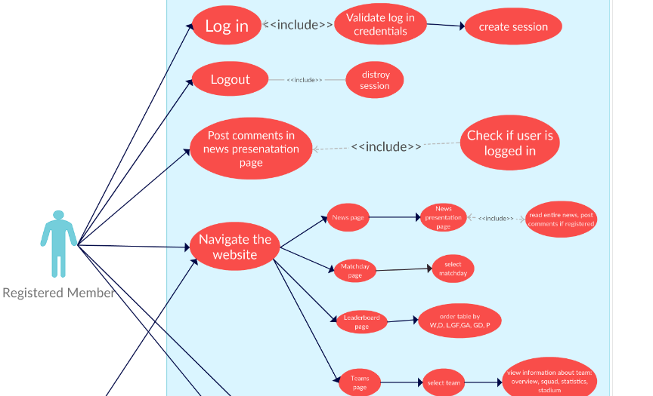

- Use case Realization:

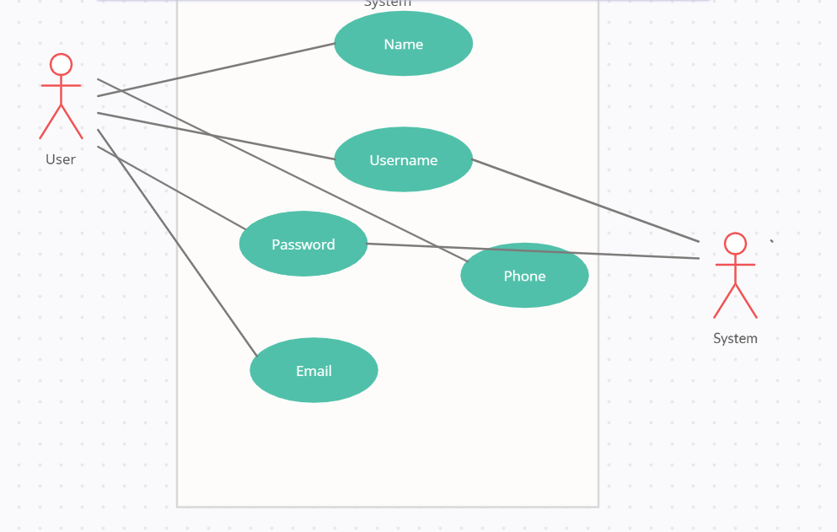

- Flow of Event or Data Flow Diagram:

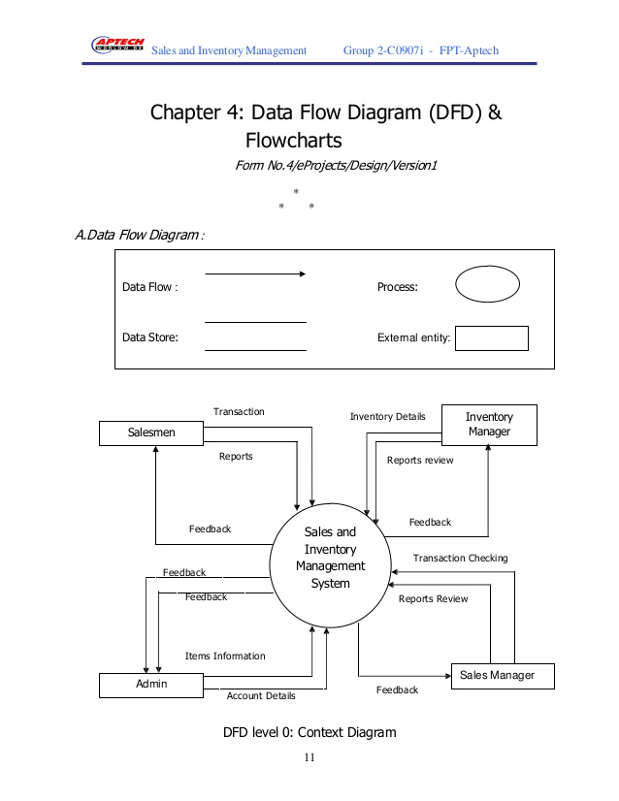

- Sequence Diagram:

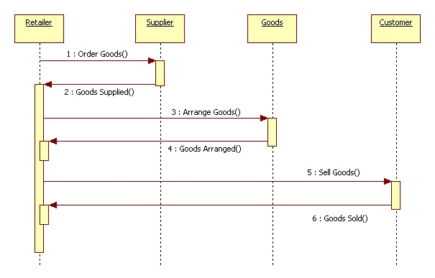

- Collaboration Diagram:

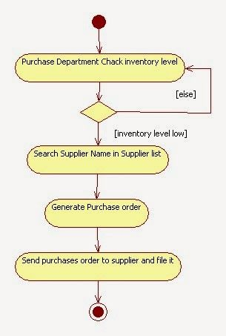

- Activity Diagram:

- Class Diagram:

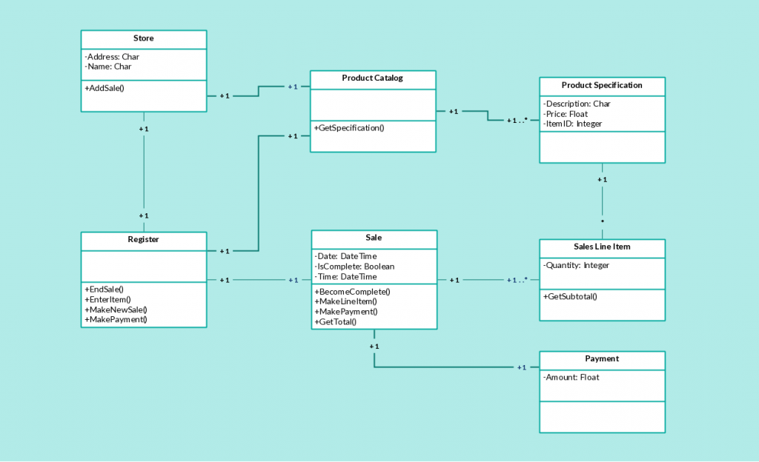

- State Chart Diagram:

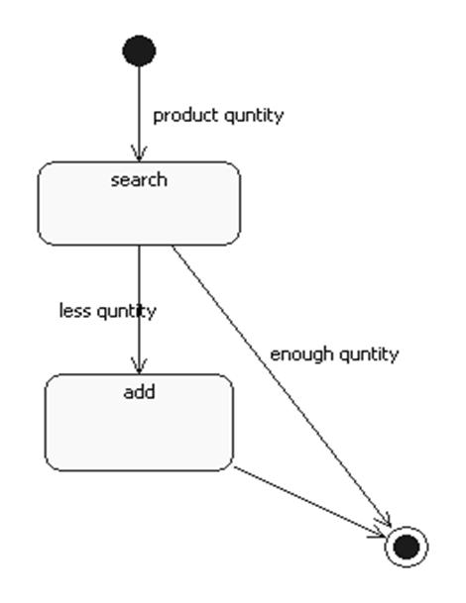

    - Module 3 Stocks/Suppliers complete CRUD Make Suppliers / Stock Function

Name : Muhammad Muzammil
ID : 9454

a) Description: This function to handle the suppliers and main record of products in the Inventory Management databases. Stocks items are updated, inserted, deleted in this function. New product can also be in added in stock, prices can be adjusted.

- Usage Scenario/ Use case Description/ Specification:

Description | [ make | drop | view | update] Add new items in stock, CRUD operation in DB
Inputs | Product name, date, expiry, price etc
Source | Name of the item, date, quantity, expiry date
Alternate Case | If the inputs are invalid or incomplete show error message “please provide complete info”
Outputs | Added | Deleted | Viewed | Modified Users
Destination | After the information is provided for the user those info will be saved in Database, then user can log into system to use the system.
Precondition | Valid information; complete info provided, all input fields are filled.
Post Condition | Access to the login screen after providing the asked information,
Side Effects | If wrong or incomplete info is provided then error message will be shown

- Use case Diagram:

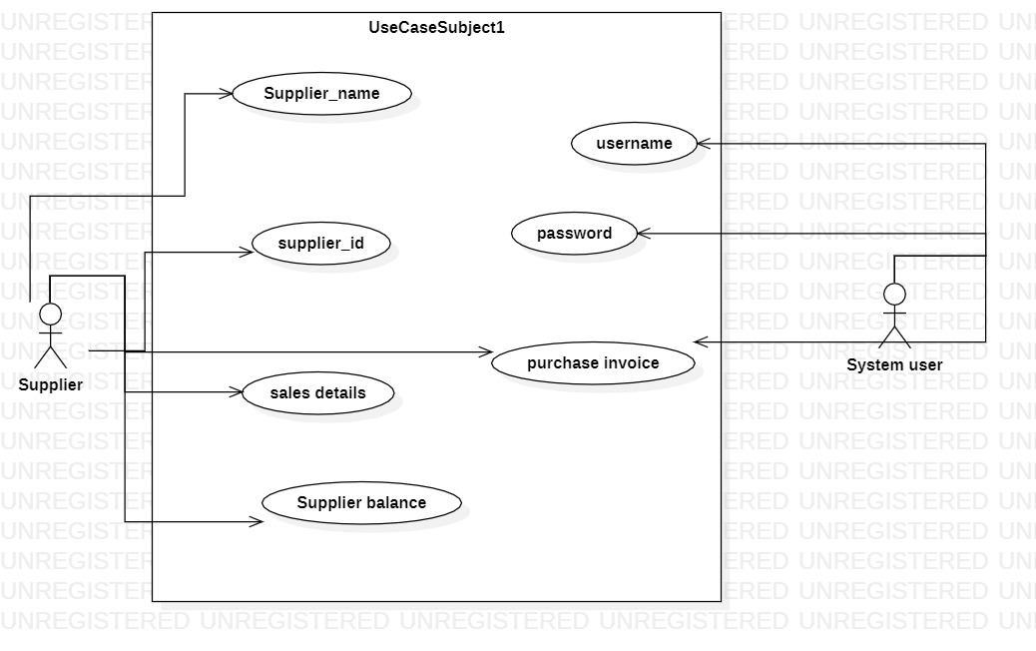

- Use case Realization:

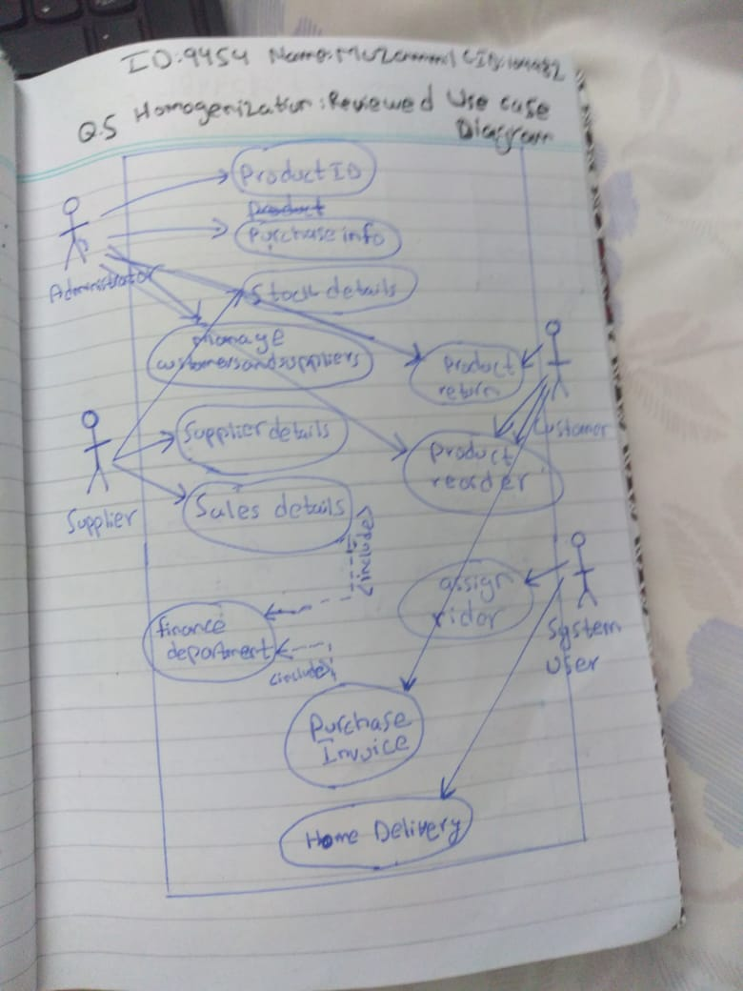

- Flow of Event or Data Flow Diagram:

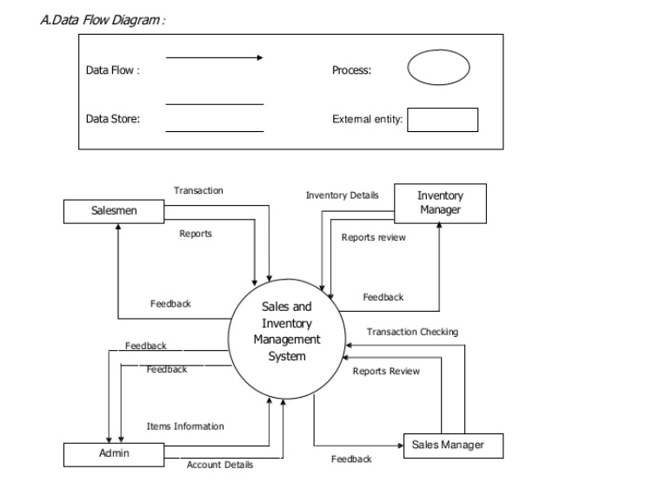

F) Sequence Diagram:

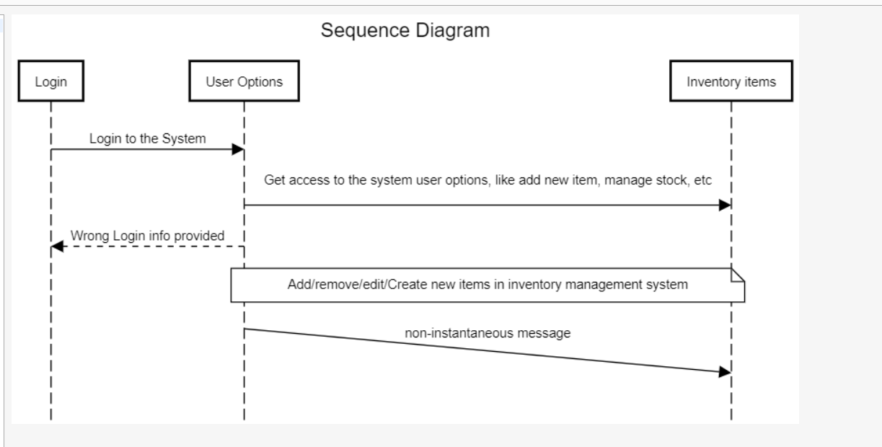

G) Collaboration Diagram:

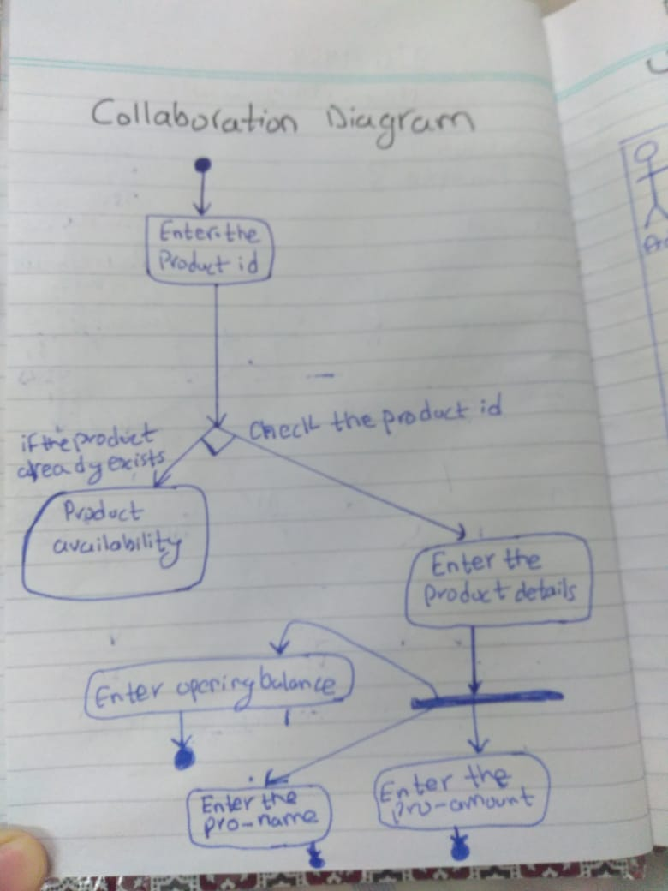
H) Activity Diagram:

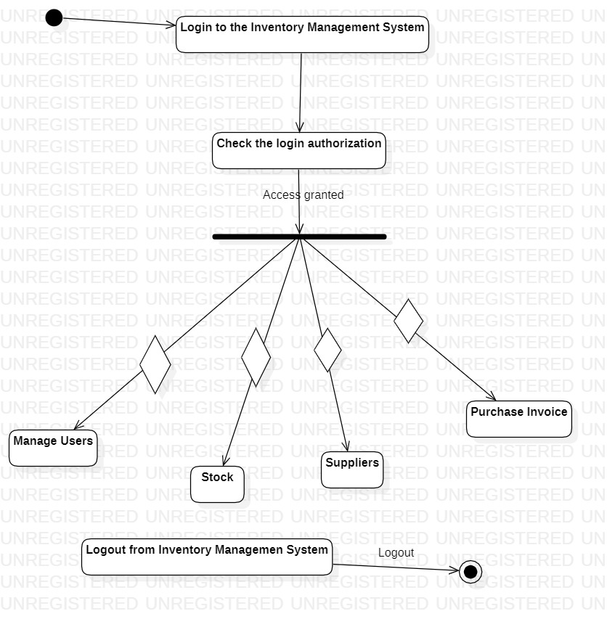

- Class Diagram:

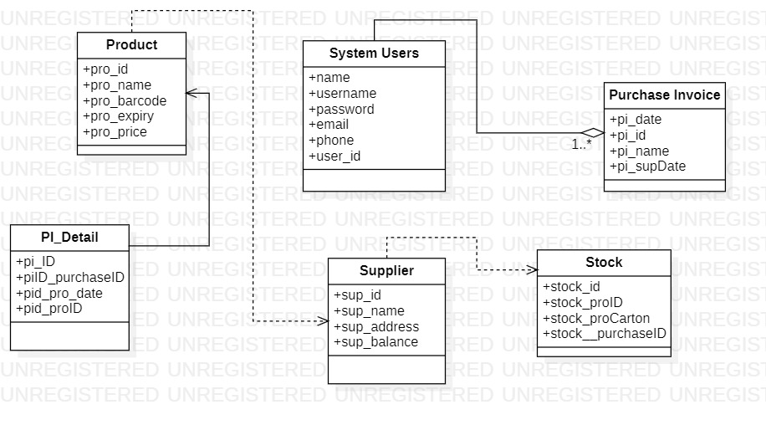

J) State Chart Diagram:

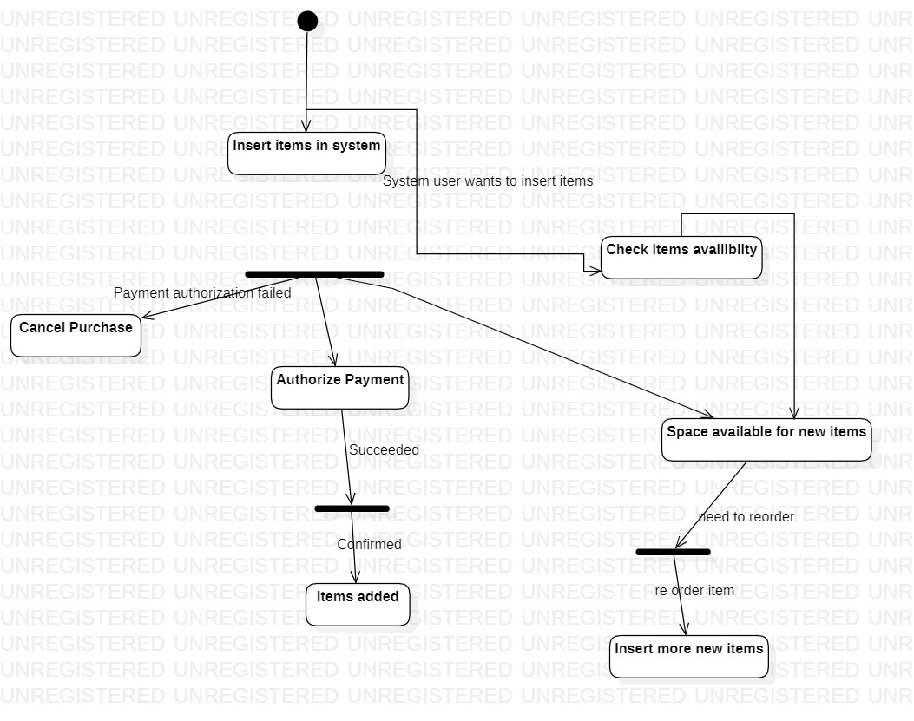

    - Module 4 complete CRUD Make the Purchase invoice/Payment options

Name : Taqi Ahmed
ID : 9762

a) Description: This function in our Inventory Management handles the Purchase invoice/Payment issues. Creates and maintain records for the sold items. Manipulate prices. All the information regarding suppliers and stock are shown here also.

- Usage Scenario/ Use case Description/ Specification:

Description | [ make | drop | view | update] Purhcase Invoice : maintain records for the sold items. Manipulate prices. All the information regarding suppliers and stock are shown here also
Inputs | Supplier balance, supplier phone, supplier address, pricing
Source | Name of the item, date, quantity, expiry date
Alternate Case | If the inputs are invalid or incomplete show error message “please provide complete info”
Outputs | Added | Deleted | Viewed | Modified purchase invoice
Destination | After the information is provided for the user those info will be saved in Database, then user can log into system to use the system.
Precondition | Valid information; complete info provided, all input fields are filled.
Post Condition | Access to the login screen after providing the asked information,
Side Effects | If wrong or incomplete info is provided then error message will be shown

- Use case Diagram:

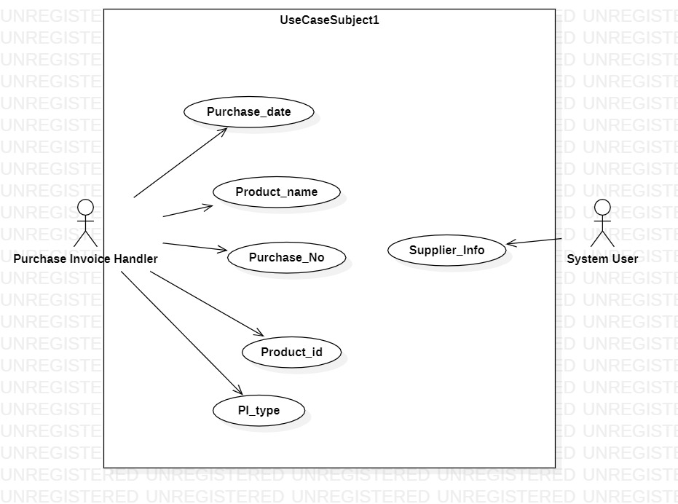

- Use case Realization:

- Flow of Event or Data Flow Diagram:

- Sequence Diagram:

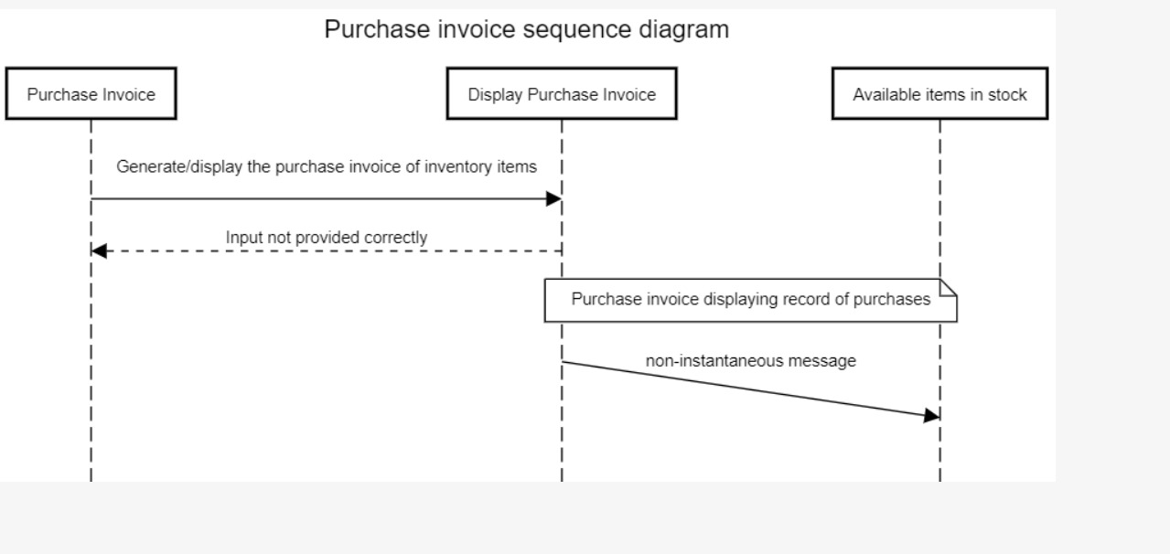

G) Collaboration Diagram:

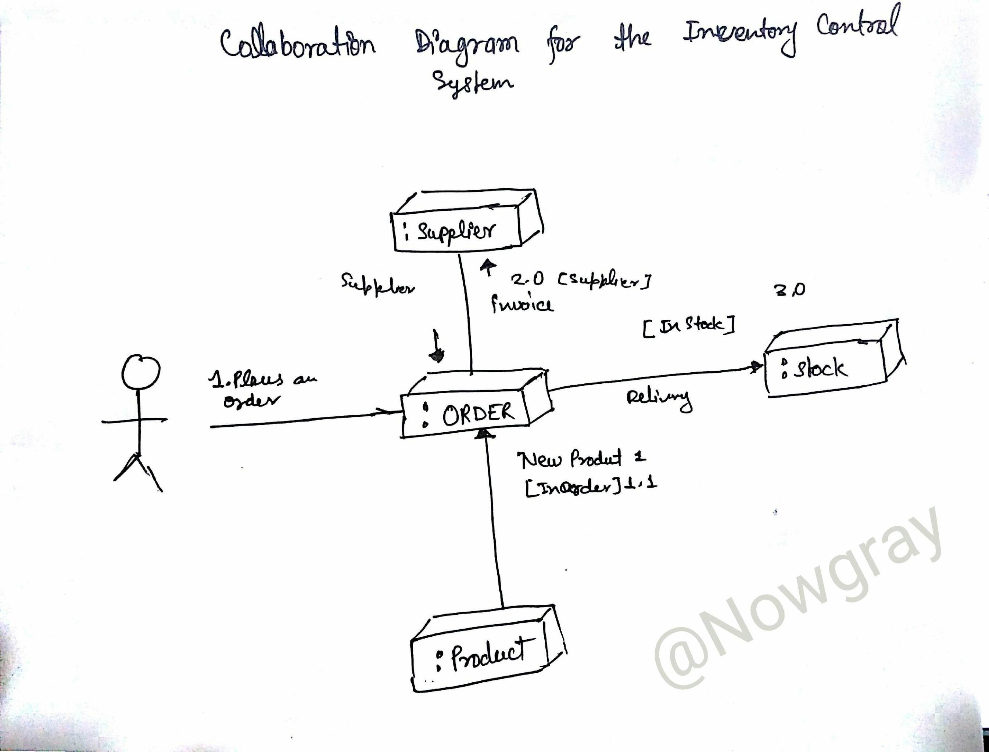

H) Activity Diagram:

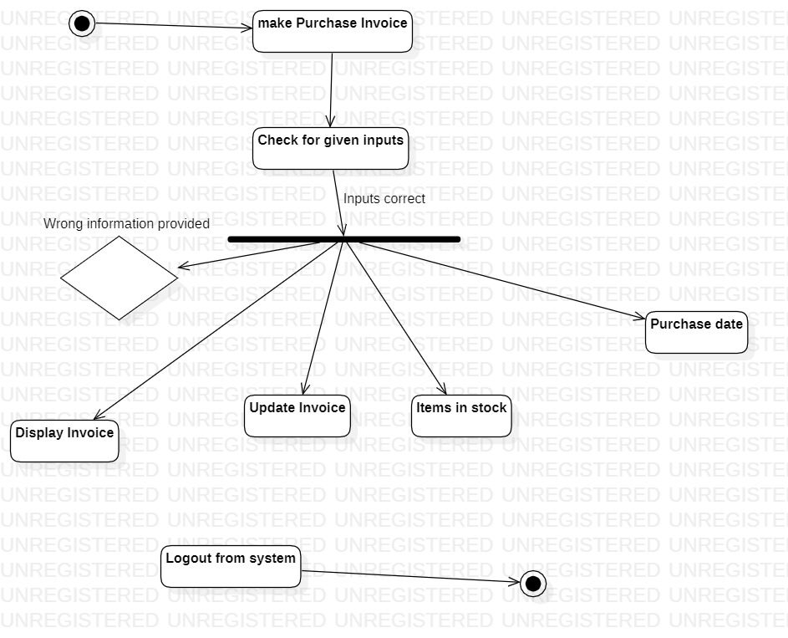

- Class Diagram:

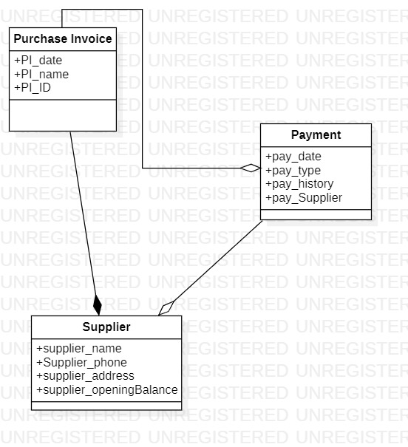

J) State Chart Diagram:

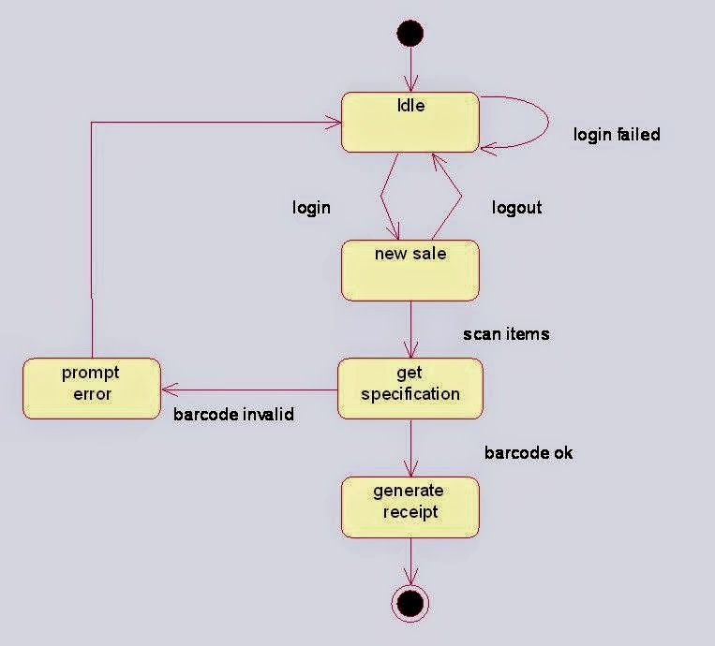

We are 3 members in the project Inventory Management System not 5.

    - Module 5 complete CRUD Make a Reservation Function
3.1.6 Module 6 complete CRUD Make a Reservation Function

3.2. External Interface Requirements
3.2.1 User Interfaces :

User Interface the Graphical User Interface in the IMS consists of various options including Users, Stock, Supplier, Purchase Invoice, Sales, etc

Initial GUI (lots of work to be done)

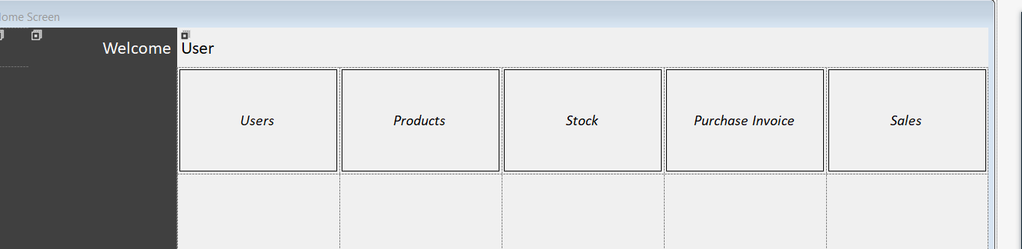

3.2.3 Software Interfaces

MS SQL Server 2012/2014 Database will be used in the project.
Visual Studio 2013 will be the IDE.

(1) Name: Apache
(2) Mnemonic: Apache
(3) Version Number: 1.3.14
(4) Source: Apache Software Foundation

3.5.3 Usability
The Inventory Management system will be developed so that it is an easy to use system that requires the least amount of user input possible. Every input will be validated. The user should only have general computer use knowledge.

